**Chatbot Application (Rule-Based)**

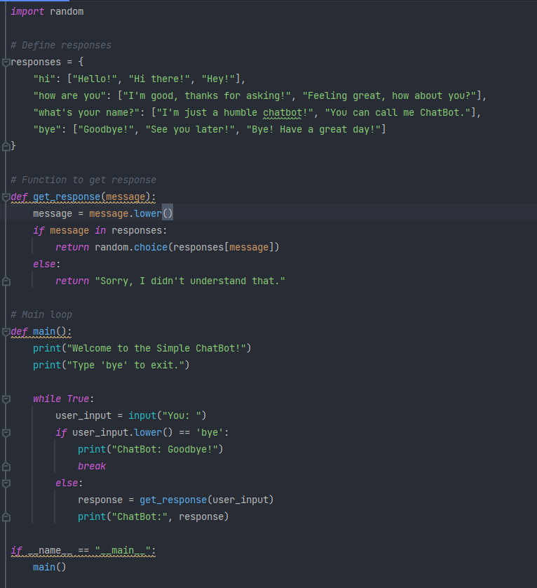

**Let's break down the code step by step:**

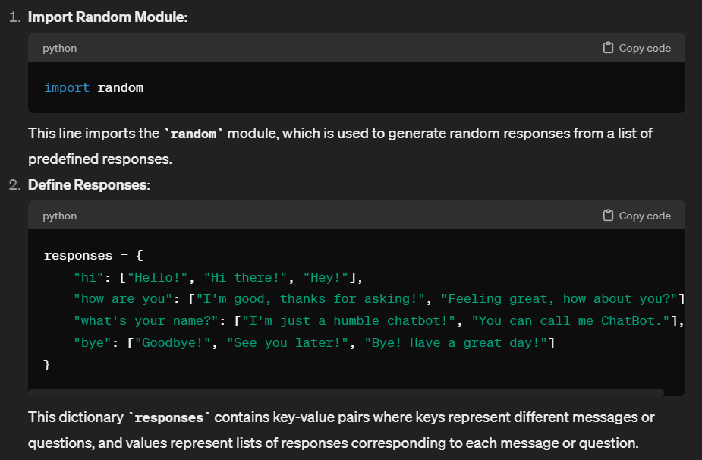

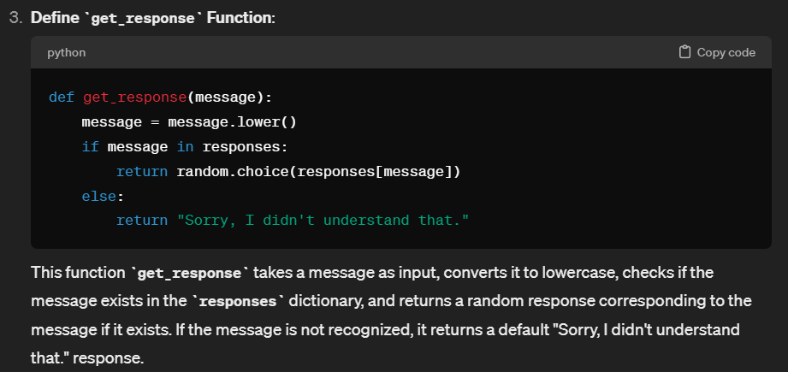

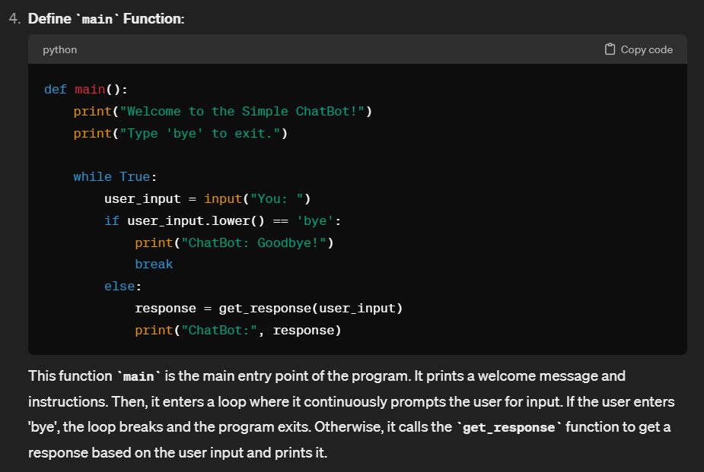

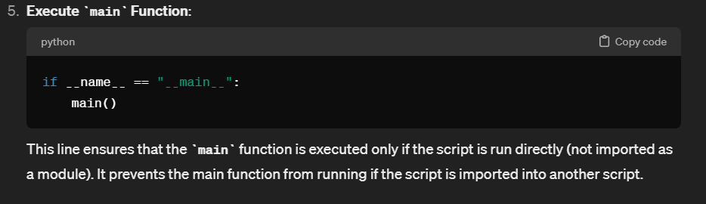

**Assignment to develop a similar chatbot application with some modifications:**

**Assignment: Develop a Simple ChatBot**

**Objective:** To create a simple chatbot application using Python, focusing on basic programming concepts like dictionaries, functions, loops, and user input/output.

**Instructions:**

1. **Functionality Requirements:**
   * The chatbot should greet the user upon startup and ask for their name.
   * The chatbot should respond to at least four different messages or questions from the user with predefined responses. These responses should be stored in a dictionary.
   * Add at least one new type of message or question and its corresponding responses to the chatbot. Ensure the responses are appropriate to the message/question.
   * The chatbot should handle unrecognized messages gracefully by responding with a default message.
   * The chatbot should allow the user to exit the conversation by typing 'bye'. Upon exiting, the chatbot should bid farewell to the user.
2. **Technical Requirements:**
   * Use functions to organize your code logically. For example, separate the response retrieval logic into a function.
   * Implement error handling to handle unexpected user inputs gracefully.
   * Ensure your code is well-documented with comments explaining the purpose of each function and significant blocks of code.
3. **Additional Features (Optional):**
   * Add a feature where the chatbot remembers the user's name and uses it in responses.
   * Implement a feature to handle multiple variations of the same message/question.
   * Integrate basic natural language processing techniques to improve the chatbot's understanding of user inputs.

**Submission Guidelines:**

* Submit a Python script (.py file) containing your chatbot implementation.
* Ensure your code follows proper coding conventions and is well-structured.
* Include a brief explanation of any additional features or modifications you have implemented beyond the basic requirements.

**Sample Output:**

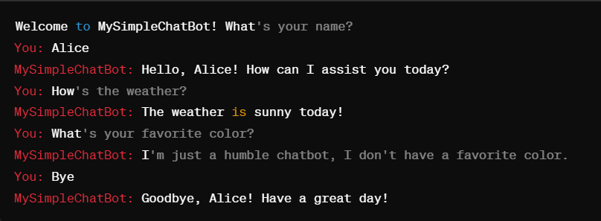

**Note:** Feel free to be creative and add more features to enhance your chatbot's functionality beyond the basic requirements. Good luck and have fun coding!